# Rat demography, flooding and socioecological mosaics of

abandonment across post-Katrina New Orleans

Bruno M. Ghersi1*, Anna C. Peterson1, Claudia Riegel3,

Richard Campanella4, James E. Childs5, Michael J. Blum1,2,6

1Department of Ecology and Evolutionary Biology, University of Tennessee, Knoxville, TN 37996

2 ByWater Institute, Tulane University, New Orleans, LA, 70118

3City of New Orleans Mosquito, Termite, Rodent Control Board, New Orleans, LA 70122

4 School of Architecture, Tulane University, New Orleans, LA 70118

5Department of Epidemiology of Microbial Disease, Yale School of Public Health, New Haven, CT 06510

6Department of Ecology and Evolutionary Biology, Tulane University, New Orleans, LA, 70118

**Keywords:** counter-urbanization,disaster, hurricane, health disparities, rodents, rodent-borne disease

**Word count:**

**Working title:** Rat demography parallels post-disaster abandonment

**\*Corresponding author:**Department of Ecology and Evolutionary Biology, University of Tennessee, Knoxville, TN 37996; bghersi@vols.utk.edu

**ABSTRACT**

Catastrophic disasters that unfold in urban environments can elevate disease risk by reconfiguring resident human and commensal communities, including arthropod-vectors and rodents and associated zoonotic and vector-borne pathogens. Post-disaster demography of urban rodent populations are determined not only by the nature of the disaster but also by the decisions and actions taken during recovery and rebuilding. Our aim was to improve understanding of disease risk across the disaster cycle by evaluating the social-ecological conditions that have shaped commensal rat populations in post-Katrina New Orleans. Rats were trapped over six seasonal periods between mid-2014 and early 2017 across 96 sites in 10 trapping areas stratified by flooding gradients and policy-driven mosaics of post-disaster abandonment. A total of 943 rats were captured over the course of 50,566 trap-nights. Of the two species trapped, Norway rats (*Rattus norvegicus*) and roof/black rats (*Rattus rattus*), roof rats were far more abundant (67.0% of total). Rats were captured at all 10 study areas and at 80% of the individual trapping sites. Black rats were more widely distributed across the city. Overall rat occurrence and abundance were higher in areas with more vacant lots, particularly during winter. The abundance of roof rats and Norway rats was greater at flood affected sites. Clusters of elevated roof and Norway rat abundance were detected in the lower-income Upper and Lower 9th Ward neighborhoods, which sustained severe flood damage and extensive abandonment. Consistent with this, we found that the fitness of roof rats was higher in flooded areas and the fitness of Norway rats was higher in lower-income areas. These results illustrate that catastrophic disasters can leave indelible socioecological signatures in affected areas. Our findings also highlight how policy-driven differences in post-disaster resettlement and rebuilding can fortify legacies of sociocultural disparity by elevating rather than alleviating potential risks to human well-being.

**INTRODUCTION**

Interest in disaster recovery is on the rise, driven in large part by the magnitude and increased frequency of extreme weather events. These once atypical occurrences are in large part attributed to climate variability which is projected to increase steadily over the next century with rising temperatures. These events will disproportionately affect populations of vulnerable coastal cities, in underdeveloped countries with large populations living in locations lacking effective infrastructure to provide health and critical resources such a clean water and sanitation even in the best of times. However, as hurricanes Katrina and Sandy demonstrated, irrespective of national wealth, no countries are spared. The population size of persons living in coastal cities is projected to double over the coming decades (Small and Nicholls 2003, Webster et al. 2005, Elsner et al. 2008, Rahmstorf and Coumou 2011, Leaning and Guha-Sapir 2013).

As work on disaster prevention and recovery has grown, so has appreciation for the possibility that response efforts can result in unanticipated and undesirable outcomes, including amplification- rather than mitigation- of public health risks (Rael et al. 2016). It is well understood that disasters can result in deleterious public health outcomes (Leaning and Guha-Sapir 2013) by disturbing built and natural environments at times enhancing conditions for the transmission of vector borne and zoonotic pathogens. Examples include increased incidence of severe and potentially fatal disease leptospirosis (Watson et al. 2007), malaria (Krishnamoorthy et al. 2005) and Rift Valley fever (Sindato et al. 2011). Concurrent displacement of hosts, pathogens and affected human populations can magnify transmission risk by increasing the likelihood of interactions (Watson et al. 2007, Murray and Daszak 2013, Rael et al. 2016). Shifts in habitat and resource availability also can increase the abundance of pathogen-hosts and vectors. For instance, storm-driven flooding can accelerate the growth of mosquito populations by producing more habitat favorable to reproduction (Weaver and Reisen 2010).

Reducing public health threats is often a principal focus of disaster response and recovery efforts (Shultz 2014), but well-intentioned response efforts can inadvertently produce or exacerbate post-disaster public health threats. For instance, relief operations can unintentionally introduce pathogens, as illustrated by the cholera outbreak after the 2010 earthquake in Haiti (Chin et al. 2010, Piarroux et al. 2011, Orata et al. 2014). Disturbance-driven ecological outcomes may also be mediated by resettlement and policy-driven disparities in post-disaster landscape management (Lewis et al. 2017). For example, relief organizations can concentrate refugees and resources, which can promote pest outbreaks and potentially increase contact with pathogen hosts or vectors. Intentional abandonment or neglect of affected areas may also elevate disease risk by augmenting harborage of pathogen hosts and vectors (Peterson et al. , Ligon 2006, Linscott 2007, Kumari et al. 2009). Thus greater understanding of social-ecological conditions associated with post-disaster zoonotic disease risk could better ensure that policies and interventions safeguard rather than worsen human well-being in affected areas (Gotham et al. 2014, Rael et al. 2016).

Studying the demography of commensal rats can provide valuable perspectives on post-disaster disease risk, particularly in disaster-stricken cities (Battersby and Greenwood 2004). Norway rats (*Rattus norvegicus*) and black/roof rats (*Rattus rattus*) are habitat-dependent pathogen reservoirs with near-global distributions (Cavia et al. 2009, Himsworth et al. 2013a, Himsworth et al. 2013b). Demographic attributes such as likelihood of presence, abundance, and size structure of both species correspond to sociocultural conditions that govern local habitat suitability and resource availability (Sinclair and Krebs 2002, Williams et al. 2002) Similarly, individual attributes like body size and condition that are correlated with survival and reproduction (Burthe et al. 2010) may track shifts in habitat and resource availability (Villafañe Isabel et al. 2013). Norway and roof rats can harbor diverse assemblages of parasites and pathogens (hereafter ‘pathogens’), including those that cause leptospirosis, plague, hemorrhagic fever with renal syndrome associated with Seoul virus ( a hantavirus maintained by members of the genus *Rattus*) and capillariasis (Himsworth et al. 2013a). Some pathogens are more strongly associated with one or the other species. Seoul virus, for example, appears to be carried only by Norway rats in New Orleans (Cross et al. 2014) although isolates were originally obtained from both species in Korea (Lee et al. 1982). Thus, when both species are present, assessing the demography of Norway and black rats may offer broader insight into post-disaster pathogen transmission risk.

Disaster-driven disturbance and post-disaster interventions can elicit demographic responses that depart from seasonal and multi-annual cycles often exhibited by rodents (Korpim et al. 1996, Oli and Dobson 1999, Lambin et al. 2000, Ims et al. 2008, Burthe et al. 2010). Responses may vary, however, depending on whether shifts in prevailing conditions result in distress, opportunity, or a combination thereof. For example, severe flooding might result in an acute spike in mortality and thus elicit local population collapse (Zhang et al. 2007), which might be followed by a wave of immigration driven by a rise in the number of abandoned buildings or aggregation of debris and refuse in flood-affected areas (Sarkar 2006). Efforts to rebuild, which sometimes involve clearing debris and removing damaged trees to restore services (e.g., electrical power), may also reduce the availability of preferred habitat of one species or another (Rael et al. 2016, Lewis et al. 2017). Thus intra- and interspecific demographic variation might arise across affected areas due to organismal factors like habitat preferences and differences in mobility among species (Zhang et al. 2007) as well as sociocultural factors like disparities in disturbance, resettlement and rebuilding (Dickman and Doncaster 1989, Eskew and Olival 2018).

In this study, we examined the demography of commensal rats across areas of New Orleans affected by Hurricane Katrina. Catastrophic flooding followed by a decade of uneven recovery has resulted in a natural laboratory for studying how public health risks are shaped by disturbance and disaster response (Peterson et al. , Rael et al. 2016, Lewis et al. 2017). We conducted a city-wide, trap-based survey to characterize demography across the city, with the aim of drawing comparisons among areas that have experienced marked differences in flooding, resettlement and post-disaster landscape management. We hypothesized that demographic variation corresponds to policy-driven differences in resettlement and rebuilding as much as or more than flooding disturbance (Lewis et al. 2017). We predicted that flood-stricken areas harbor more rats as a result of social-ecological disparities in abandonment and municipal differences in vacant lot management (*sensu* LaDeau et al. 2013). Accordingly, studying conditions across post-Katrina New Orleans not only shed further light on the urban ecology of commensal rats, it also offered valuable perspective on sociocultural disparities in public health risks that could guide the development of more equitable policies and practices intended to ensure human well-being after disasters.

**METHODS**

***Study area, site selection & trapping.*** Hurricane Katrina devastated the City of New Orleans on 29 August 2005. Nearly 70% of all occupied housing units suffered damage from hurricane winds or flooding following 50 breaches in drainage canal and navigational levees. Over 80% of the east bank of the city flooded, with water rising to over 15 feet in some areas (Plyer 2014). Mass exodus from the city reduced the population from ~485,000 (April 2000) to ~230,000 (July 2006) Though the population has since returned to >85% of pre-Katrina residency, resettlement has been uneven across the city, with some areas exhibiting little to no recovery (Fussel et al. 2014, Lewis et al. 2017). As has been documented in other cities affected by hurricane-driven flooding (e.g., areas of New York City affected by Super Storm Sandy in 2012 (Savage et al. 2018)), Katrina-related wind and flooding also reshaped ecological communities across New Orleans. For example, a sequence of biotic surveys showed that the abundance of urban birds and mammals was lower following the storm (Yaukey 2008), and that demographic recovery was relatively slow and uneven, with concordant shifts in dominance arising in the years following the storm (Yaukey 2012). Remote-sensing based comparisons of land cover also indicate that Katrina-related flooding reduced landscape diversity across the city (Gotham et al. 2014), though vegetation surveys found that plant community composition reflected municipal differences in post-disaster landscape management as much or more than Katrina-related flooding (Lewis et al. 2017). Notably, post-Katrina management has given rise to mosaics of abandonment and ‘green blight’ areas that have fortified long-standing legacies of sociocultural disparities across the city (Lewis et al. 2017).

To characterize the distribution and demography of commensal rats*,* we trapped animals at 96 sites distributed across eight neighborhoods in Orleans parish, an adjacent neighborhood in St Bernard Parish, and an adjacent natural area (Figure 1). The study areas were chosen to capture variation in Katrina-related flooding, income, abandonment, and post-Katrina vacant lot management (described in Lewis et al. 2017 and Peterson et al. 2020). In each study area, we trapped at a random subset of eight to ten sites distributed across a base network of 500+ plots previously used for complementary surveys of land use, vegetation and microhabitat conditions (Gotham et al. 2014, Lewis et al. 2017). Since rats do not typically move >200 m from a nesting site (Heiberg et al. 2012), trapping sites within residential areas corresponded to city blocks, and trapping sites in the natural area were equivalent to an average-sized city block across our residential study areas. Except for the French Quarter, St Bernard Parish and the natural area, we trapped at all sites twice a year (summer and winter) in 2014-2015, 2015-2016, and 2016-2017 (Table 1). We only trapped in the French Quarter once in 2014-2015 and twice in both 2015-2016 and 2016-2016, whereas we trapped in the natural area in 2015-2016 and 2016-2017, and St Bernard Parish in 2016-2017 (Table 1).

During each trapping period, traps were set outside in yards, alleys and vacant lots in areas exhibiting signs of potential or observed rodent activity. We set 30 tomahawk traps at each site for a minimum of three continuous nights, with trapping sustained until the trap rate reached an approximate asymptote (i.e., we “trapped out” a site). Traps were baited and set at dusk and checked early the following morning. Non-target species were immediately released (with the event recorded to correct estimates of trapping effort and success) All rats were transported to the City of New Orleans Mosquito, Termites and Rodent Control Board facilities to be euthanized and necropsied in accordance with Tulane-approved IACUC protocols 0451 and 0460.

***Measurement of individual attributes***. After euthanasia, we determined species identity and measured weight and length attributes (e.g., full body length, tail length, right hind limb and ear length). We also recorded sex, sexual maturity (determined based on visible scrotal testes in male and a perforate vagina in females) as well as parity (i.e., the presence of placental scarring/active pregnancy) and the number of embryos present in pregnant females (Aplin 2003). Age classes were defined by body weight for both sexes and species (McGuire et al. 2006, King et al. 2011). Roof rat males with a mass <110 g and females with a mass <80 g were classified as juveniles, males between 110 g and 140 g and females between 80 g and 120 g were classified as subadults, whereas males >140 g and females >120 g were classified as adults. All Norway rats <80 g were classified as juveniles whereas males between 80 g and 200 g and females between 80 g and 180 g were classified as subadults, and males >200 g and females >180 g were classified as adults. Body condition was estimated for all individuals using a Standard Mass Index (SMI) based on body mass and full body length (Peig and Green 2009).

***Estimates of occupancy and abundance.*** A site was considered occupied if at least one individual from either species was captured during the sampling period. Because measuring absolute abundance was not feasible (Blackwell et al. 2002), we relied on two methods to estimate relative abundance: (1) trap success; and (2) hierarchical models based on removal counts. Trap success was quantified from the number of animals caught per unit of sampling effort (i.e., trap-nights) (Beauvais and Buskirk 1999), correcting for sprung but empty traps and non-target species (Beauvais and Buskirk 1999). Relative abundance also was determined from removal counts using the functions “gmultmix” and “multinomPois” in the Unmarked package of R, which estimates the super population size at a site despite imperfect detection by fitting hierarchical models (Fiske and Chandler 2011, Dénes et al. 2015). We used a generalized multi-mix model with random effects to estimate site abundance for each species at each site based on capture-removal data from the first four days of trapping (Peterson et al. 2020). Unmarked also was used to assess within-site abundance by season and year using a Poisson model with random effects.

***Characterization of socio-environmental conditions.*** Surface elevation – a proxy for flooding depth - was estimated from LIDAR with reference to water level data from Lake Pontchartrain (Gesch 2006). As described elsewhere (Gotham et al. 2014, Lewis et al. 2017, Peterson et al. 2020), land cover classification was performed on three multispectral 0.5 m resolution satellite images of the study area taken in mid-to-late March 2014, 2015 and 2016. Using ESRI ArcGIS 10.3.1, we completed a supervised classification of five land cover categories: mature trees, open grass, urban surface/bare soil, buildings, and open water (Gotham et al. 2014, Lewis et al. 2017). Using US Census block boundaries for residential areas and 250 x 250 m polygons for the natural area, we validated and improved classifications for each trapping site through visual inspection and by referencing GIS layers delineating building footprints and open water bodies. We also referenced parcel boundaries (htpps://www.gis.nola.gov: https://gis-stbernard.opendata.arcgis.com) and a corresponding time-series of Google Earth images to determine the number and proportion of vacant lots (i.e., a lot without a built structure) on each residential trapping block. All trapping sites outside of residential areas (all sites in the natural area, one location within a city park, and one area fully located along a roadside) were designated 100% vacant. Additionally, during each trapping bout we counted the number of unmaintained buildings and debris piles as well as estimated the proportion of coverage within each area that corresponded to unmaintained vegetation (grass > 6 inches high and bushes < 6 inches from the ground) at each site. Finally, we used the 2010 decennial American Community Survey (ACS) data base as another source of block level information on vacancy and the number of residents, whereas we used the 5-year block group projection of household income from the 2011 ACS.

***Spatiotemporal variation in individual attributes, occupancy and abundance***. We used chi-square tests to compare the proportion of individuals in each age class between seasons, whereas we used t-tests to determine whether body mass and SMI differed between males and females for each species. We used chi-square tests to determine whether the proportion of occupied sites differed by each species and to determine which species exhibited a broader distribution across the study area. We used ArcGIS to visualize variation in the overall estimated number and distribution of rats across the study area. Getis-Ord Gi* was used to identify clusters of high and low estimates of rat abundance with trapping site (i.e., city block or equivalent) serving as the unit of analysis. Additionally, we conducted ANOVAs with post-hoc Tukey tests to determine whether individual attributes (e.g., age class, gender, SMI values, etc.), species occurrence, trap success rate and relative abundance differed among study areas. Paired t-tests also were conducted to assess whether each parameter categorically differed according to mean household income (above or below the city average: US$42196), flooding (flooded versus unflooded), and species co-occurrence (one versus two species present). For all tests, significance was determined when α was ≤0.05.

***Predictors of individual attributes, occupancy and abundance***. We used generalized linear mixed modeling (glm) to determine whether log-transformed SMI and body mass reflected a set of variables that have proven to be informative in past studies of urban rats (e.g., Peterson et al. 2020). Prior to completing the analysis, we checked all potential predictors for collinearity. We removed the remotely-sensed estimates of grass cover and building cover as they were correlated with the proportion of vacant lots at a trapping site (r = 0.48, and -0.61, both p < 0.05). We also removed the remotely-sensed measure of impervious surface cover as it was correlated with the remotely-sensed measure of tree cover (r = -0.53, p < 0.05). Thus for overall and species-level measures of SMI and body mass, global models included measures of year, flooding depth, median household income, number of residents, remotely-sensed estimates of tree cover and the proportion of vacant lots at each study site (hereafter ‘vacancy’), as well as survey-based estimates of unmaintained buildings, debris, unmaintained vegetation, and the interactions of household income x flooding depth, unmaintained buildings x flooding depth, vacancy x flooding depth, vacancy x season, and vacancy x unmaintained vegetation as fixed effects. All predictor variables were standardized to a mean of 0 and a variance of 1, which allows for the assessment of effect size through direct comparison of coefficients (Jackson et al. 2012). We included site as a random effect to account for the uneven distribution of individuals. For each analysis, all possible models were generated and ranked according to AIC score using the package MuMin. The top-selected model was determined according to the lowest AIC score. Competitive models had a score ≤2 greater than the top-selected model.

We also used a glm approach to determine predictors of overall Norway rat and roof rat occupancy and abundance with the set of explanatory variables used in glms of SMI and body mass. Due to a strong correlation between super population estimates and trapping rates per site (r = 0.97 for roof rats and r = 0.94 for Norway rats, both p < 0.05), we focused on estimated population sizes in our regression analysis of abundance. All predictor variables were standardized to a mean of 0 and a variance of 1 (Jackson et al. 2012), and while the glms for occupancy had a binomial error distribution, the glms for abundance had a negative binomial error distribution. AIC model selection was then undertaken as described above.

**RESULTS**

***Trapping***. A total of 943 (roof rats, n = 629; Norway n = 314) were trapped over 50,566 trap-nights. Rats were captured in all 10 study areas and at 77 of the 96 trapping sites (Figure 1). The overall trap success rate was 1.9%, although rates varied between sites, study areas and seasons (Table 2, Figure 1S). Besides capturing Norway and roof rats, we trapped a number of non-target species, including: cotton rats, rice rats, raccoons, opossums, house cats, and an assortment of birds, toads, squirrels, turtles, and snakes.

***Demographic and individual attributes***. Of the roof rats trapped 291 were male and 330 were female and among Norway rats 153 were male and 157 female. The proportion of trapped males-to-females did not differ by species, study area y or by season(all, p > 0.05). The mean body mass of roof rats was 117.3 g (se = 1.9), and the corresponding mean SMI was 114.1. While there were no significant differences in the average body mass of Norway rats among study areas (all, p > 0.05), the average body mass of roof rats captured in the natural area was higher than for those trapped in Gentilly, the Upper 9th Ward, the Lower 9th Ward, Lakeshore and Lakeview (Figure 4S). Consistent with this, body mass did not differ by resident average income, flooding or species co-occurrence (all, p > 0.05). Likewise, there were no significant differences in mean SMI of Norway rats among study areas (all, p > 0.05), but the mean SMI of roof rats captured in Gentilly was higher than for those trapped in Lakeshore (p < 0.05) (Figure 5S). Roof rats also exhibited a higher SMI at flooded sites (mean = 117.5, se = 1.91) than at non-flooded sites (mean = 105.1, se = 1.39) (p < 0.001), while Norway rats exhibited a higher SMI (p = 0.04) at lower income sites (mean = 220.97, se = 7.73) than at higher income sites (mean = 203.3, se = 3.53).

According to body mass measurements, 8.7% of the trapped Norway rats were juveniles, 26.8% were subadults and 64.5% were adults (Figure 6S). There was no difference in the proportion of Norway rats in each age class between summer and winter trapping bouts (all, p > 0.05), but the proportion of juvenile Norway rats in the Upper 9th Ward was higher than in the Lower 9th Ward (p < 0.02) (Figure 6S). Body mass measurements indicated that 34% of roof rats were juveniles, 25.6% were subadults and 40% were adults (Figure 6S). While juvenile and adult individuals were evenly sampled in summer and winter (both, p > 0.05), there was a greater proportion of subadult roof rats trapped during winter (p = 0.004) (Figure 6S). We did not observe any difference in the proportion of age classes for roof rats among study areas (p > 0.05).

***Estimates of occupancy and rat abundance***. Contrary to pre-study expectations, roof rats were far more prevalent than Norway rats across the study region (Figure 1). Roof rats were trapped at more sites (71 of 96; 74%) than Norway rats (38 of 96; 40% sites) (p < 0.001). Consistent with this, roof rats were more broadly distributed across the study region (Figure 1); they were captured at more sites across all study areas except in the French Quarter (p < 0.05). Though Norway rats were present in all study areas, they were only abundant in three residential neighborhoods: the French Quarter, a tourist area with high concentrations of restaurants, bars, stores and residents; the Upper 9th Ward, an area that sustained extensive Katrina-related flooding and has a relatively high amount of abandonment; and the Lower 9th Ward, which also sustained heavy flooding and which exhibits even a higher amount of abandonment than the Upper 9th Ward. Despite prior work suggesting that Norway rats outcompete roof rats when in syntopy, both species were found at 34 sites and were consistently trapped (i.e., over at least three seasons) at ten sites across the study area (Figure 1). Overall rat occurrence was greater at sites that did not flood than sites that did (p < 0.04), although no differences were found for species-level comparisons (both, p > 0.05), or according to mean household income (p > 0.05).

Roof rats also were more locally abundant at trapped sites within an area than were Norway rats. Estimated population sizes for roof rats ranged from 5 to 30 individuals (mean = 9.18, mode = 7), while estimated population sizes for Norway rats ranged from 0 to 16 individuals at a site (mean = 1.78, mode = 0). Geographic clusters of high and low population densities were observed for both species (Figure 1), with Norway rats exhibiting fewer and smaller clusters. Roof rats were more abundant in the Lower 9th ward than in the Bywater, French Quarter, Lakeview, Uptown, and St Bernard neighborhoods, as well as the natural area (all, p < 0.05). Roof rats also were more abundant in the Upper 9th Ward than in the French Quarter. Norway rats were more abundant in the Lower 9th and Upper 9th wards than in any other neighborhood but the French Quarter (otherwise all, p < 0.05). Overall trap rate was higher at sites that flooded (2.4%) than sites that did not (1.1%) (p < 0.01). Overall trap rate also was higher at lower-income sites (2.5%) than higher-income sites (1.3%) (p < 0.01). Similarly, estimated population sizes of Norway and roof rats were higher at sites that flooded (0.58, 1.14 respectively) than sites that did not (0.33, 0.70 respectively) (p < 0.05, p < 0.005), and were higher at lower-income sites (0.79, 1.23 respectively) than higher-income sites (0.25, 0.76 respectively) (p < 0.001, p < 0.01).

***Socio-environmental predictors of individual attributes, occupancy and abundance.*** The top selected models for body mass, SMI, occurrence and abundance were >2 ΔAIC than the next best models, and thus are the only models for which results are presented.

Flood depth (coef. = -0.12, p < 0.05) and vacancy (coef. = 0.07, p < 0.05) were significant predictors of overall body mass, whereas vacancy (coef. = 0.11, p < 0.001), tree cover (coef. = -0.06, p<0.01) and unmaintained buildings (coef. = 0.03, p < 0.06) were significant predictors of overall SMI. Vacancy (coef. = 0.03, p < 0.01) was a predictor of roof rat body mass, while number of residents (coef. = -0.47, p < 0.001) was a predictor of Norway rat body mass. Similarly, vacancy (coef. =0.03, p < 0.01) was a predictor of roof rat SMI, while flood depth (coef. = -0.04, p < 0.05), tree cover (coef. = 0.03, p < 0.05), and income (coef. = -0.002, p < 0.05) were predictors of Norway rat SMI.

The fixed effects variables included in the top selected model for rat occurrence were: season, flood depth, vacancy, debris, and the interactions of vacancy x flood depth, and vacancy x season (Table 2). Season was the strongest predictor of overall rat occurrence (coef. = -0.51, p = 0.01), followed by the vacancy x flood depth interaction term (coef. = 0.44, p = 0.01) (Table 2). Different socio-environmental variables predicted individual species occurrence (Table 2). The vacancy x flood depth interaction term was the strongest predictor of roof rat occurrence (coef. = 0.53, p < 0.003), followed by the vacancy x season interaction term (coef. = 0.44, p < 0.04) and tree cover (coef. = 0.37, p < 0.05). The number of residents was the strongest predictor of Norway rat occurrence (coef. = -3.90, p < 0.00) followed by flood depth (coef. = 1.17, p < 0.05) and season (coef. = -0.63, p < 0.05) (Table 2). Though there was some variability among neighborhoods (Figure 1S), total rat, Norway rat, and roof rat occurrences were lower in winter (Table 2).

The fixed effects variables included in the top selected model for total rat abundance were: season, flood depth, vacancy, debris, unmaintained vegetation, unmaintained buildings and the interaction of vacancy x flood depth, and vacancy x season (Table 3). Season was the strongest predictor of overall rat abundance (coef. = -0.41, p < 0.01) (Table 3), followed by the vacancy x season (coef. = 0.35, p < 0,05) and the vacancy x flood depth (coef. = 0.32, p < 0.05) interaction terms. Different socio-environmental variables predicted individual species abundances (Table 3). Roof rat abundance was higher in areas with greater flood depth (coef. = 0.59, p < 0.01) and unmaintained vegetation (coef. = 0.27, p < 0.05), while Norway rat abundance decreased with increasing numbers of residents (coef. =-2.3, p < 0.05), but was positively associated with the vacancy x flood depth interaction term (coef. = 0.78, p < 0.05) (Table 3) and unmaintained buildings (coef. = 0.15, p < 0.05). Though there was some variability among neighborhoods (Table 1), total rat, Norway rat, and roof rat abundances were lower in winter (Table 3).

**DISCUSSION**

To our knowledge, we have completed one of the most comprehensive quantitative trap-based studies of urban rat demography that has ever been attempted. This effort yielded unexpected findings, such as evidence that roof rats are more widely distributed and more abundant than Norway rats in New Orleans. With one notable exception (the French Quarter), roof rats were trapped at more sites and were more abundant in each study area. And, while it has long been assumed that Norway rats outcompete and displace roof rats ([Barnett and Spencer 1951](#_ENREF_2" \o "Barnett, 1951 #61)), we found clear evidence of co-occurrence. This finding is consistent with evidence from a trap-based study (Peterson et al. 2020) of rodent assemblage structure in New Orleans indicating that there is no negative association between the two species. It is also consistent with a recent report suggesting that temporal and dietary niche partitioning allows for species co-occurrence in a peri-urban greenway (Mori et al. 2019), though evidence that co-occurrence is concentrated in areas with more abandonment (i.e., the Upper and Lower 9th wards) supports the premise that unmanaged green spaces (i.e., green blight) offer sufficient habitat and resources to allow for species co-existence (Cavia et al. 2009, Peterson et al. 2020). This is well illustrated by the finding that debris and unmaintained vegetation were predictors of rat occurrence and abundance, particularly during winter when resources are more limited (Tables 2 & 3, Figures 2 & 3) (Masi et al. 2010, Peterson et al. 2020).

We found signatures of demographic responses to Katrina-related flooding across New Orleans. While this finding is not especially surprising, as prior studies of New Orleans and elsewhere (e.g., New York City) have found that catastrophic flooding can reshape ecological communities in affected areas (Yaukey 2012, Lewis 2017, Savage et al. 2018), we did not expect to find more rats in flood-affected areas. Catastrophic flooding can decimate rodent populations, with the magnitude of loss and time to recovery contingent on flooding severity ([Zhang et al. 2007](#_ENREF_54" \o "Zhang, 2007 #1105)). Thus we expected that commensal rats would be less abundant in neighborhoods at the lowest elevations and nearest to levee breaches that exhibit the highest rates of Katrina-related flooding disturbance (Gotham et al. 2014, Lewis et al. 2017). To the contrary, our results indicate that both Norway and roof rats have instead been flourishing in some of the most severely flooded areas of the city, including the Upper and Lower 9th Wards (Figures 1 & 2).

The unexpected finding of more and fitter rats in a particular subset of flood-affected areas parallels evidence from vegetation surveys that vacancy and landscape management have shaped the ecology of the city as much or more so than flooding disturbance (Lewis et al. 2017). Our results indicate that commensal rat demography corresponds to the prevalence of vacant unmaintained properties (Figures 1-3), which are unevenly distributed across flood-affected areas of the city. Notably, Lewis et al. (2017) showed that severe and prolonged flooding did not always translate into higher rates of vacancy or abandonment. The distribution of vacancy instead resulted from discriminatory implementation of resettlement and recovery programs that reinforced historically persistent income and racial disparities across the city (Talarchek 1990, Gulachenski et al. 2016, Lewis et al. 2017, Campanella 2018). Legacies of disinvestment combined with a policy of determining grants to homeowners based on pre-Katrina property value inhibited population return in lower-to-middle income black-majority areas of the city, even in neighborhoods with high levels of home ownership before the storm (Campanella 2007, Gotham and Campanella 2011, Gotham and Greenberg 2014, Campanella 2018). Our findings indicate, however, that vacancy alone is not sufficient to elevate rat abundance. Rather, abundance appears to increase as a result of neglect or limited maintenance of vacant lots (Figure 3). This is well illustrated by the striking difference in rat abundance between the Lower 9th Ward and adjacent areas of St Bernard Parish. Even though both areas exhibit similar levels of vacancy, the well-curated landscapes of St Bernard Parish harbor significantly smaller rat populations than the ruderal mosaics found in the Lower 9th Ward (Table 1, Figures 1 & 2). This, along with the recovery of broader relationships between rat abundance and indicators of landscape maintenance (Tables 1 & 2) that reflect disparities in housing recovery (Lewis et al. 2017), illustrates that post-disaster land management has acted in conjunction with vacancy and flooding to structure commensal rat demography across post-Katrina New Orleans.

It is becoming clear that disaster response and recovery can inadvertently create conditions that reinforce or inflate public health risks, particularly in historically underserved communities (Shultz 2014, Rael et al. 2016, Lewis et al. 2017). Here we examined whether social-ecological outcomes of Hurricane Katrina have been mediated by uneven resettlement and post-disaster landscape management across New Orleans. We hypothesized that a combination of Katrina-related flooding and policy-driven disparities in abandonment of affected areas (Lewis et al. 2017) has augmented harborage for commensal rats that can host pathogens of human concern (Peterson et al. , Ligon 2006, Linscott 2007, Kumari et al. 2009). As hypothesized, city-wide trapping showed that rats are more abundant and in better condition in flood-affected areas burdened with more abandonment, substantiated by greater prevalence of vacant lots, debris, and unmaintained vegetation. This, along with evidence that abandonment is disproportionately concentrated in lower income, historically marginalized communities (Gulachenski et al. 2016, Lewis et al. 2017), illustrates that disparities in post-disaster resettlement and response can reinforce legacies of environmental injustice. Global parallels in social geography (e.g., Gulachenski et al. 2016, Anderson et al. 2020) suggest that these findings can be instructive for other cities and regions that are recovering from catastrophic natural and technical disasters (e.g., Fukushima Prefecture, Japan), and perhaps socio-economic trauma (e.g., economic decline) that can elicit counter-urbanization (LaDeau et al. 2013, Rael et al. 2016, Eskew and Olival 2018).

Surveying conditions across post-Katrina New Orleans offered valuable perspectives on the urban ecology of commensal rats.

This study demonstrates that careful consideration of social-ecological outcomes of disaster-driven disturbance, (re)settlement and land use can improve disaster planning and recovery. Our findings highlight how discriminatory and neglectful policies can coalesce to increase disparities in public health risk, where historically underserved communities become burdened with abandoned properties harboring rats that can carry pathogens of human concern (Peterson et al. 2017, Eskew and Olival 2018, Rael et al. 2018). Our work also points to the possibility that taking proactive measures like removing debris, razing blighted buildings, and mowing vacant lots can reduce pathogen exposure risk. Further inquiry and development of ‘disaster ecology’ theory and tools (Rael et al. 2016) could similarly guide the progression of decision-making across the disaster cycle, from first-responders to municipal entities (Corrigan 2006), to establish successive lines of defense against public health threats. This will better ensure that policies and responses not only safeguard well-being, but also address legacies of sociocultural disparity days to decades after a disaster.

**ACKNOWLEDGEMENTS**

We would like to thank the Tulane-Xavier Center for Bioenvironmental Research, the Tulane ByWater Institute, the National Science Foundation (BCS-0948993, BCS-1313703), and the Louisiana Board of Regents for funding this work. We would also like to thank the following people for supporting the study: S. Meaux, A. Lesen, J. Lewis, R. Hazen, T. Madere, R. Rael, W. Zipperer, F. Bauder, T. Barre, A. Balliviero, P. Smith, A. Gulachenski, E. Ruda, S. Piper, H. Rahn, S. Sugarman, R. Wang, H. Patel, A. Tun, S. Triplett, A. Powell, and J. Haydel.

**REFERENCES**

Anderson, P., Charles-Dominique, T., Ernstson, H., Andersson, E., Goodness, J. and T. Elmqvist. 2020. Post-apartheid ecologies in the City of Cape Town: An examination of plant functional traits in relation to urban gradients. Landscape and Urban Planning **193:** 103662.

Aplin, K. P., Brown, P.R., Jacob, J., Krebs, C.J. and Singleton, G.R. 2003. Field methods for rodent studies in Asia and the Indo-Pacific. Page 223 *in* ACIAR, editor.

Barnett, S. A., and M. M. Spencer. 1951. Feeding, Social Behaviour and Interspecific Competition in Wild Rats. Behaviour **3**:229-242.

Battersby, J. E., and J. J. D. Greenwood. 2004. Monitoring terrestrial mammals in the UK: past, present and future, using lessons from the bird world. Mammal Review **34**:3-29.

Beauvais, G. P., and S. W. Buskirk. 1999. Modifying estimates of sampling effort to account for sprung traps. Wildlife Society Bulletin **27**:39-43.

Blackwell, G. L., M. A. Potter, and J. A. McLennan. 2002. Rodent density indices from tracking tunnels, snap-traps and Fenn traps: do they tell the same story? New Zealand Journal of Ecology **26**:43-51.

Burthe, S. J., X. Lambin, S. Telfer, A. Douglas, P. Beldomenico, A. Smith, and M. Begon. 2010. Individual growth rates in natural field vole, Microtus agrestis, populations exhibiting cyclic population dynamics. Oecologia **162**:653-661.

Cavia, R., G. R. Cueto, and O. V. Suarez. 2009. Changes in rodent communities according to the landscape structure in an urban ecosystem. Landscape Urb Plan **90**:11.

Chin, C.-S., J. Sorenson, J. B. Harris, W. P. Robins, R. C. Charles, R. R. Jean-Charles, J. Bullard, D. R. Webster, A. Kasarskis, P. Peluso, E. E. Paxinos, Y. Yamaichi, S. B. Calderwood, J. J. Mekalanos, E. E. Schadt, and M. K. Waldor. 2010. The Origin of the Haitian Cholera Outbreak Strain. New England Journal of Medicine **364**:33-42.

Cross, R. W., B. Waffa, A. Freeman, C. Riegel, L. M. Moses, A. Bennett, D. Safronetz, E. R. Fischer, H. Feldmann, T. G. Voss, and D. G. Bausch. 2014. Old World hantaviruses in rodents in New Orleans, Louisiana. Am J Trop Med Hyg **90**:897-901.

Dénes, F. V., L. F. Silveira, and S. R. Beissinger. 2015. Estimating abundance of unmarked animal populations: accounting for imperfect detection and other sources of zero inflation. Methods in Ecology and Evolution **6**:543-556.

Dickman, C. R., and C. P. Doncaster. 1989. The Ecology of Small Mammals in Urban Habitats .2. Demography and Dispersal. Journal of Animal Ecology **58**:119-127.

Elsner, J. B., J. P. Kossin, and T. H. Jagger. 2008. The increasing intensity of the strongest tropical cyclones. Nature (London) **455**:92-95.

Eskew, E. A., and K. J. Olival. 2018. De-urbanization and Zoonotic Disease Risk. Ecohealth **15**:707-712.

Fiske, I., and R. Chandler. 2011. unmarked: An R Package for Fitting Hierarchical Models of Wildlife Occurrence and Abundance. 2011 **43**:23.

Gesch, D. B. 2006. Topography-based Analysis of Hurricane Katrina Inundation of New Orleans.*in* G. Farris, G. Smith, M. Crane, C. Demas, L. Robbins, and D. Lavoie, editors. Science and the Storms: the USGS Response to the Hurricanes of 2005. U.S. Geological Survey.

Gotham, K. F., M. J. Blum, and R. Campanella. 2014. Toward a New Normal: Trauma, Diversity, and the New Orleans Urban Long-Term Research Area Exploratory (ULTRA-Ex) Project. Cities and the Environment (CATE) **7**.

Heiberg, A. C., V. Sluydts, and H. Leirs. 2012. Uncovering the secret lives of sewer rats (Rattus norvegicus): movements, distribution and population dynamics revealed by a capture-mark-recapture study. Wildlife Research **39**:202-219.

Himsworth, C., A. T. Feng, K. Parsons, T. Kerr, and D. Patrick. 2013a. Using experiential knowledge to understand urban rat ecology: A survey of Canadian pest control professionals. Urban Ecosystems **16**:341-350.

Himsworth, C. G., J. Bidulka, K. L. Parsons, A. Y. Feng, P. Tang, C. M. Jardine, T. Kerr, S. Mak, J. Robinson, and D. M. Patrick. 2013b. Ecology of Leptospira interrogans in Norway rats (Rattus norvegicus) in an inner-city neighborhood of Vancouver, Canada. PLoS Negl Trop Dis **7**:e2270.

Ims, R. A., J. A. Henden, and S. T. Killengreen. 2008. Collapsing population cycles. Trends in Ecology & Evolution **23**:79-86.

King, C. M., J. G. Innes, D. M. Gleeson, N. Fitzgerald, T. Winstanley, B. O’Brien, L. J. Bridgman, and N. R. Cox. 2011. Reinvasion by ship rats (Rattus rattus) of forest fragments after eradication. Biological Invasions **13**:2391-2408.

Korpim, xe, E. ki, and C. J. Krebs. 1996. Predation and Population Cycles of Small Mammals. BioScience **46**:754-764.

Krishnamoorthy, K., P. Jambulingam, R. Natarajan, A. N. Shriram, P. K. Das, and S. C. Sehgal. 2005. Altered environment and risk of malaria outbreak in South Andaman, Andaman & Nicobar Islands, India affected by tsunami disaster. Malaria Journal **4**.

Kumari, R., P. L. Joshi, S. Lal, and W. Shah. 2009. Management of malaria threat following tsunami in Andaman & Nicobar Islands, India and impact of altered environment created by tsunami on malaria situation of the islands. Acta Tropica **112**:204-211.

Lambin, X., S. J. Petty, and J. L. MacKinnon. 2000. Cyclic dynamics in field vole populations and generalist predation. Journal of Animal Ecology **69**:106-118.

Leaning, J., and D. Guha-Sapir. 2013. Natural disasters, armed conflict, and public health. N Engl J Med **369**:1836-1842.

LeDuc, J. W., G. A. Smith, and K. M. Johnson. 1984. Hantaan-like viruses from domestic rats captured in the United States. Am.J.Trop.Med.Hyg. **33**:992-998.

Lee, H. W., L. J. Baek, and K. M. Johnson. 1982. Isolation of Hantaan virus, the etiologic agent of Korean hemorrhagic fever, from wild urban rats. J.Infect.Dis. **146**:638-644.

Lewis, J. A., W. C. Zipperer, H. Ernstson, B. Bernik, R. Hazen, T. Elmqvist, and M. J. Blum. 2017. Socioecological disparities in New Orleans following Hurricane Katrina. Ecosphere **8**.

Ligon, B. L. 2006. Infectious Diseases that Pose Specific Challenges After Natural Disasters: A Review. Seminars in Pediatric Infectious Diseases **17**:36-45.

Linscott, A. J. 2007. Natural disasters — a microbe's paradise. Clinical Microbiology Newsletter **29**:57-62.

McGuire, B., T. Pizzuto, W. E. Bemis, and L. L. Getz. 2006. General Ecology of a Rural Population of Norway Rats (Rattus norvegicus) Based on Intensive Live Trapping. BIOONE.

Murray, K. A., and P. Daszak. 2013. Human ecology in pathogenic landscapes: two hypotheses on how land use change drives viral emergence. Curr Opin Virol **3**:79-83.

Oli, M. K., and F. S. Dobson. 1999. Population Cycles in Small Mammals: The Role of Age at Sexual Maturity. Oikos **86**:557-565.

Orata, F. D., P. S. Keim, and Y. Boucher. 2014. The 2010 cholera outbreak in Haiti: how science solved a controversy. PLoS Pathog **10**:e1003967.

Peig, J., and A. J. Green. 2009. New perspectives for estimating body condition from mass/length data: the scaled mass index as an alternative method. Oikos **118**:1883-1891.

Peterson, A. C., B. M. Ghersi, R. Campanella, C. Riegel, J. A. Lewis, and M. J. Blum. Rodent assemblage structure reflects socioecological mosaics of counter-urbanization across post-Katrina New Orleans. Landscape and Urban Planning.

Piarroux, R., R. Barrais, B. Faucher, R. Haus, M. Piarroux, J. Gaudart, R. Magloire, and D. Raoult. 2011. Understanding the cholera epidemic, Haiti. Emerging Infectious Diseases **17**:1161-1168.

*Plyer, A.* 2014. Facts for Features: Katrina Impact.

Rael, R. C., A. C. Peterson, B. M. Ghersi, J. Childs, and M. J. Blum. 2016. Disturbance, Reassembly, and Disease Risk in Socioecological Systems. Ecohealth.

Rahmstorf, S., and D. Coumou. 2011. Increase of extreme events in a warming world. Proceedings of the National Academy of Sciences of the United States of America **108**:17905-17909.

Sarkar, R. 2006. Post Earthquake Debris Management - An Overview. Advances in Geosciences **9: Solid eath, Ocean Science & Atmospheric Science**:11.

Savage, A. M., E. Youngsteadt, A. F. Ernst, S. A. Powers, R. R. Dunn, and S. D. Frank. 2018. Homogenizing an urban habitat mosaic: arthropod diversity declines in New York City parks after Super Storm Sandy. Ecol Appl **28**:225-236.

Shultz, J. M. 2014. Perspectives on disaster public health and disaster behavioral health integration. Disaster Health **2**:69-74.

Sinclair, A. R. E., and C. J. Krebs. 2002. Complex numerical responses to top-down and bottom-up processes in vertebrate populations. Philosophical Transactions of the Royal Society of London Series B-Biological Sciences **357**:1221-1231.

Sindato, C., E. Karimuribo, and L. E. Mboera. 2011. The epidemiology and socio-economic impact of rift valley fever epidemics in Tanzania: a review. Tanzan J Health Res **13**:305-318.

Small, C., and R. J. Nicholls. 2003. A global analysis of human settlement in coastal zones. Journal of Coastal Research **19**:584-599.

Villafañe Isabel, E. G., R. Cavia, M. Victoria Vadell, V. Suárez Olga, and M. Busch. 2013. Differences in population parameters of Rattus norvegicus in urban and rural habitats of central Argentina. Page 187 mammalia.

Watson, J. T., M. Gayer, and M. A. Connolly. 2007. Epidemics after natural disasters. Emerg Infect Dis **13**:1-5.

Weaver, S. C., and W. K. Reisen. 2010. Present and future arboviral threats. Antiviral Research **85**:328-345.

Webster, P. J., G. J. Holland, J. A. Curry, and H. R. Chang. 2005. Changes in tropical cyclone number, duration, and intensity in a warming environment. Science (Washington D C) **309**:1844-1846,1838.

Williams, B. K., J. D. Nichols, and M. J. Conroy. 2002. Analysis and Management of Animal Populations. Elsevier Science.

Yaukey, P. 2012. Population changes of urban land birds in the three years following the hurricane Katrina flood. Natural Hazards: Journal of the International Society for the Prevention and Mitigation of Natural Hazards **61**:14.

Zhang, M., K. Wang, Y. Wang, C. Guo, B. Li, and H. Huang. 2007. Recovery of a rodent community in an agro-ecosystem after flooding. Journal of Zoology **272**:138-147.

**Table 1.** **Mean trap rate (top) and population size estimates (bottom) with standard deviations (in parenthesis) by season and trapping area.**

|  |  |  |  |  |  |  |
| --- | --- | --- | --- | --- | --- | --- |
|  | **2014-2015** | | **2015-2016** | | **2016-2017** | |
| **Trapping Area** | **Summer** | **Winter** | **Summer** | **Winter** | **Summer** | **Winter** |
| Bywater | 0.76 (1.75) | 0.46 (0.59) | 1.51 (1.69) | 0.67 (0.94) | 0.22 (0.47) | 0.46 (1.45) |
|  | 0.60 (1.58) | 0.40 (0.52) | 1.60 (1.90) | 0.60 (0.83) | 0.40 (0.52) | 0.40 (1.26) |
| French Quarter | -- | 1.17 (1.55) | 1.61 (1.82) | 1.33 (2.65) | 2.19 (4.47) | 2.50 (3.40) |
|  | -- | 1.00 (1.31) | 1.63 (1.69) | 1.25 (2.37) | 1.63 (3.11) | 2.25 (3.06) |
| Gentilly | 1.65 (1.92) | 0.84 (1.14) | 1.21 (1.83) | 1.33 (2.20) | 2.08 (2.86) | 0.56 (0.95) |
|  | 1.80 (2.04) | 0.90 (1.29) | 1.20 (1.99) | 1.50 (2.72) | 1.70 (2.00) | 0.50 (0.85) |
| Lakeshore | 1.70 (2.25) | 0.99 (1.35) | 2.35 (2.06) | 1.34 (2.33) | 1.00 (0.98) | 0.31 (0.50) |
|  | 1.70 (2.21) | 1.00 (1.33) | 2.10 (1.79) | 1.20 (2.10) | 0.90 (0.88) | 0.30 (0.48) |
| Lakeview | 0.45 (1.08) | 0.11 (0.36) | 0.45 (1.08) | 0.85 (1.02) | 2.63 (8.32) | 0.34 (0.75) |
|  | 0.50 (1.27) | 0.10 (0.32) | 0.50 (1.27) | 0.80 (1.03) | 1.20 (3.79) | 0.30 (0.67) |
| Lower 9th Ward | 4.26 (4.83) | 3.05 (3.72) | 4.56 (3.95) | 3.68 (3.24) | 2.00 (1.80) | 3.91 (3.62) |
|  | 5.50 (7.11) | 2.70 (3.23) | 4.80 (5.29) | 4.00 (3.89) | 2.00 (2.11) | 4.00 (3.86) |
| Natural area | -- | -- | 1.03 (1.71) | 1.16 (2.09) | 0.88 (1.21) | 0.48 (0.98) |
|  | -- | -- | 0.63 (1.41) | 1.00 (2.45) | 0.25 (0.46) | 0.50 (1.07) |
| Upper 9th Ward | 3.58 (3.68) | 3.24 (2.21) | 3.87 (3.97) | 2.23 (3.16) | 1.04 (1.48) | 0.78 (1.49) |
|  | 3.00 (3.16) | 3.30 (2.45) | 3.40 (3.44) | 2.60 (4.09) | 0.90 (1.29) | 0.70 (1.34) |
| Uptown | 0.69 (1.02) | 0.27 (0.62) | 0.70 (0.81) | 0.75 (0.99) | 1.50 (1.78) | 1.46 (2.85) |
|  | 0.60 (0.84) | 0.30 (0.67) | 0.60 (0.70) | 0.80 (1.03) | 1.40 (1.29) | 1.60 (3.44) |
| St Bernard Parish | -- | -- | -- | -- | 0.35 (0.77) | 0.24 (0.77) |
|  | -- | -- | -- | -- | 0.30 (0.67) | 0.20 (0.63) |
| All | 1.87 (2.93) | 1.27 (2.05) | 1.95 (2.65) | 1.49 (2.31) | 1.38 (3.24) | 1.09 (2.21) |
|  | 1.96 (3.54) | 1.22 (1.95) | 1.86 (2.81) | 1.55 (2.65) | 1.07 (1.94) | 1.06 (2.27) |

**Table 2. Coefficients and significance of socio-environmental variables included in the top models of occurrence.** The magnitude of fixed effects variables indicates the influence of a given variable on total rat abundance, Norway rat abundance, or roof rat abundance. Terms in bold are statistically significant (p < 0.05).

|  |  |  |  |
| --- | --- | --- | --- |
| **Variable** | **All rats Coefficient** | **Norway rat Coefficient** | **Roof rat Coefficient** |
| Intercept | -0.03 | **-1.92** | -0.47 |
| Debris | 0.23 | - - | 0.21 |
| Flood Depth | -0.04 | **1.17** | 0.14 |
| Median household Income | - - | **-0.03** | - - |
| Number of residents | - - | **-3.90** | - - |
| Season (winter) | **-0.51** | **-0.63** | -0.37 |
| Tree cover | - - | **-0.62** | **0.37** |
| Unmaintained vegetation | - - | 0.31 | - - |
| Vacancy | 0.15 | - - | -0.10 |
| Vacancy x flood depth | **0.44** | -**0.03** | **0.53** |
| Vacancy x season (winter) | 0.40 | - - | **0.44** |

**Table 3. Coefficients and significance of socio-environmental variables included in the top models of abundance**. The magnitude of fixed effects variables indicates the influence of a given variable on total rat abundance as well as Norway rat and roof rat abundance. Terms in bold are statistically significant (p < 0.05).

|  |  |  |  |
| --- | --- | --- | --- |
| **Variable** | **All rats Coefficient** | **Norway rat Coefficient** | **Roof rat Coefficient** |
| Intercept | -0.06 | **-2.29** | -0.43 |
| Debris | 0.11 | - - | 0.07 |
| Flood depth | -0.01 | **-0.35** | **0.59** |
| Median household income | - - | **-0.01** | 0.01 |
| Number of residents | - - | **-2.30** | - - |
| Season (winter) | **-0.41** | **-0.67** | **-0.36** |
| Unmaintained buildings | 0.11 | **0.15** | - - |
| Unmaintained vegetation | 0.16 | - - | **0.27** |
| Vacancy | 0.18 | 0.28 | -0.02 |
| Median household income x flood depth | - - | - - | **-0.01** |
| Vacancy x flood depth | **0.32** | **0.78** | - - |
| Vacancy x season (winter) | **0.35** | **0.42** | **0.35** |

**Figure 1.** (Top) Spatial distribution of population estimates for each trapping site by species. (Bottom) Spatial clustering of high and low abundance of each species based on Getis-Ord GI* analysis. Study areas are delineated by orange boundaries.

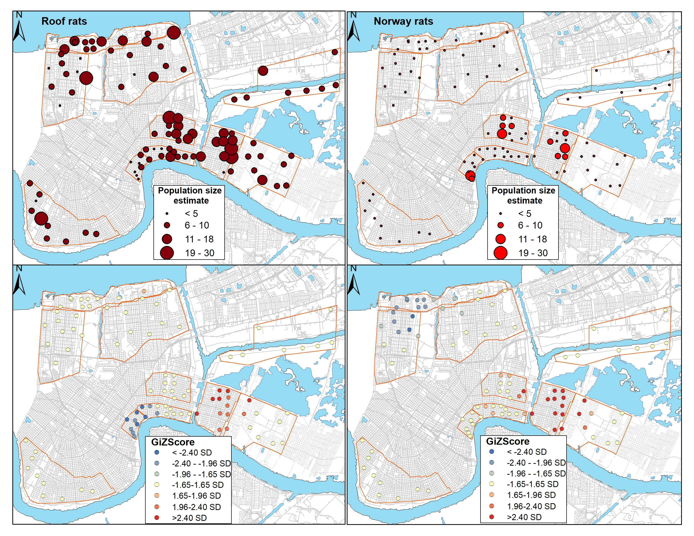

**Figure 2.** Relationship between vacancy on the probability of rat occurrence relative to flooding (top) and season (bottom, winter versus summer trapping bouts). Rat occurrence increased with vacancy at flooded sites, but not unflooded sites. Rat occurrence more sharply increased with vacancy during winter versus summer trapping bouts.

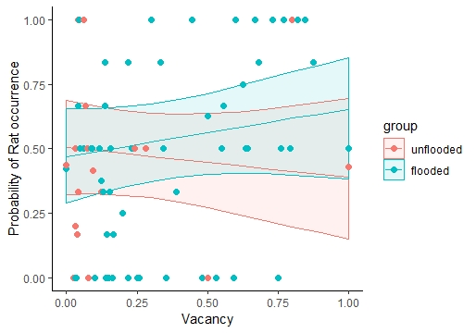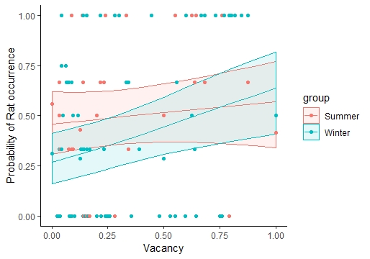

**Figure 3**. Relationship between unmaintained vegetation- an indicator of abandonment- on total rat abundance per site relative to vacancy (top; high, >50%; low, <50%) and season (bottom, winter versus summer trapping bouts). We observed greater abundance relative to unmaintained vegetation in areas with high vacancy. Similarly, abundance was greater relative to unmaintained vegetation during winter.

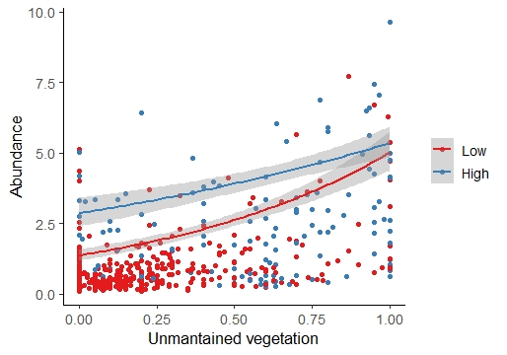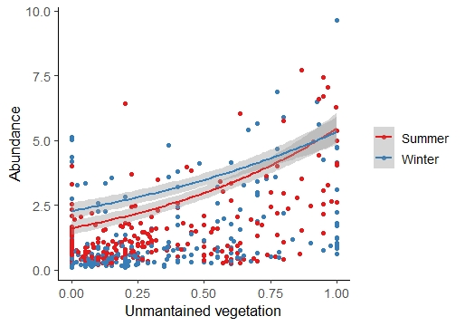

**SUPPLEMENTAL MATERIAL**

**Figure 1S.** Overall trap rate by season and year with reference to Katrina-related flood depth.

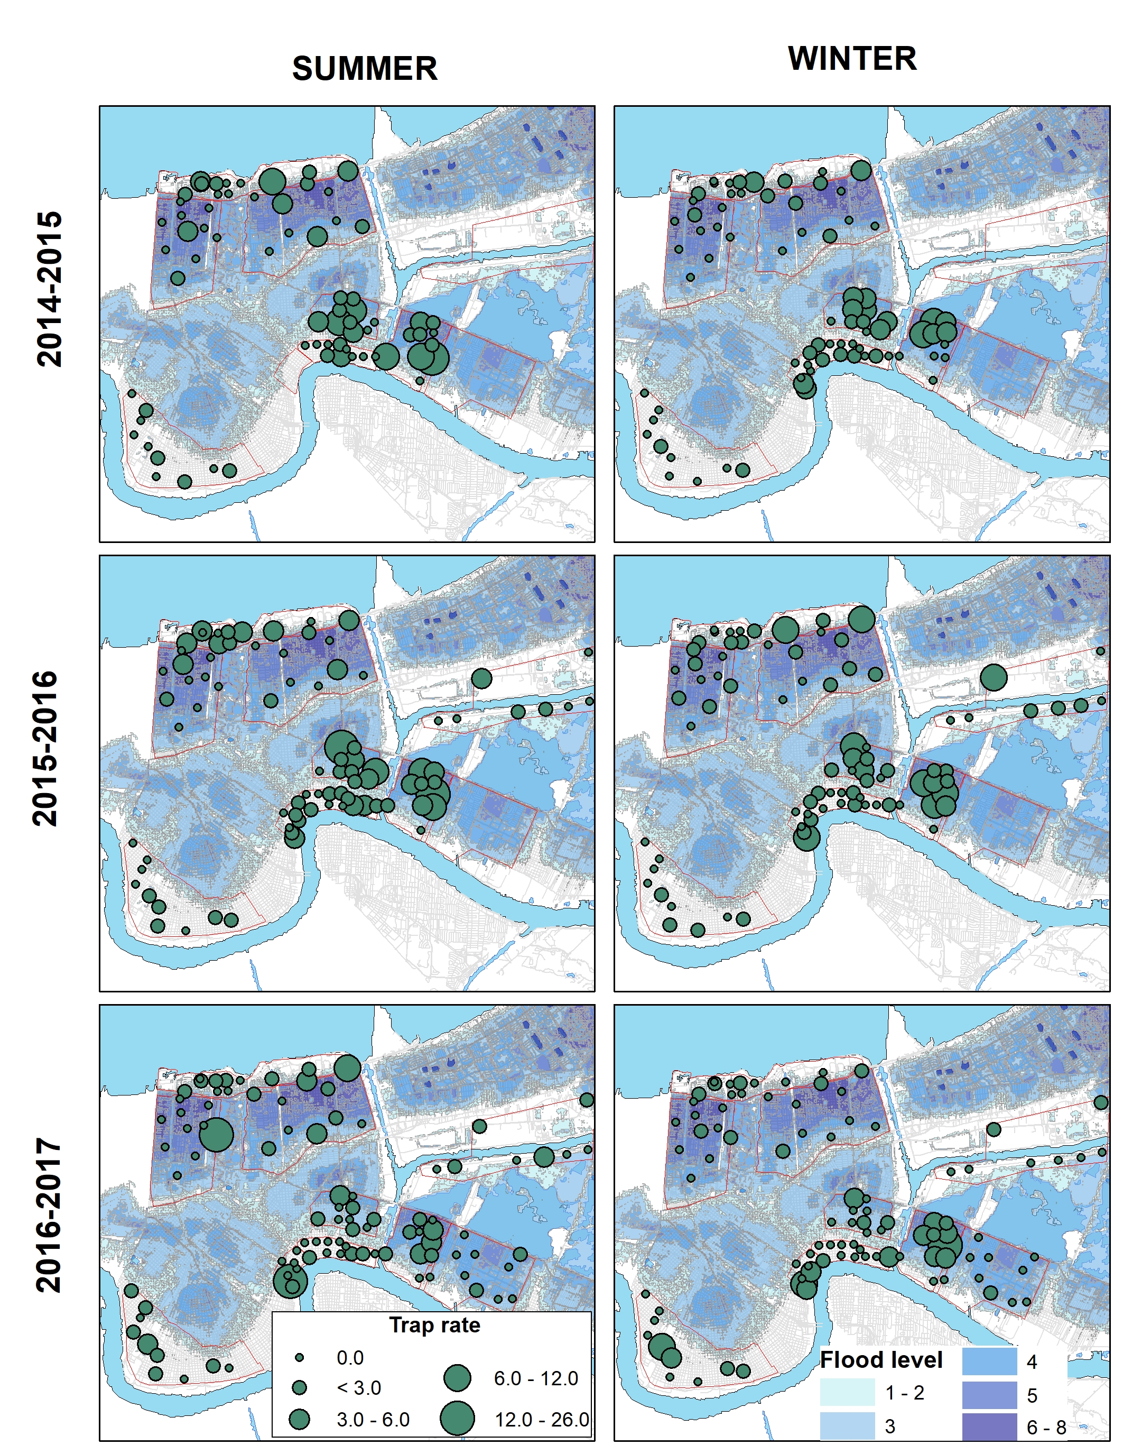

**Figure 2S.**  Dstribution of body mass (top) and SMI (bottom) of roof rats by sex.

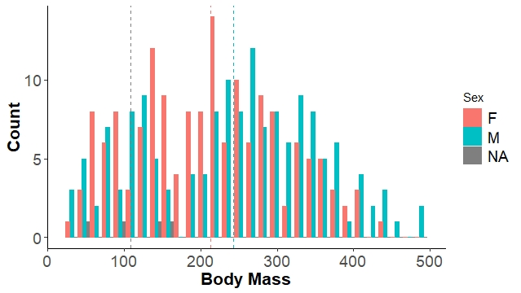

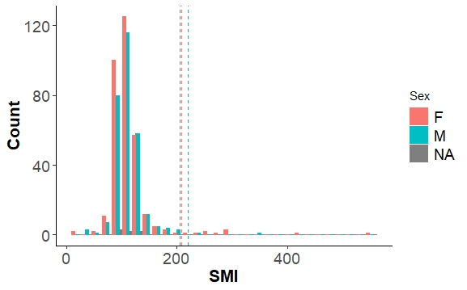

**Figure 3S.**

Distribution of body mass (top) and SMI (bottom) of Norway rats by sex.

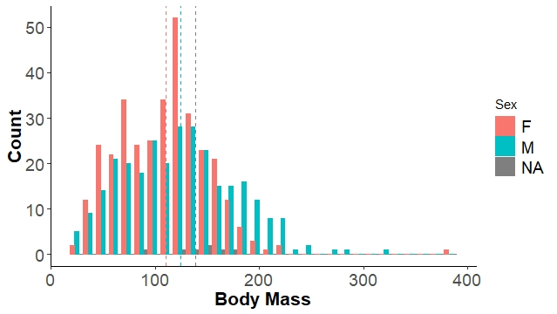

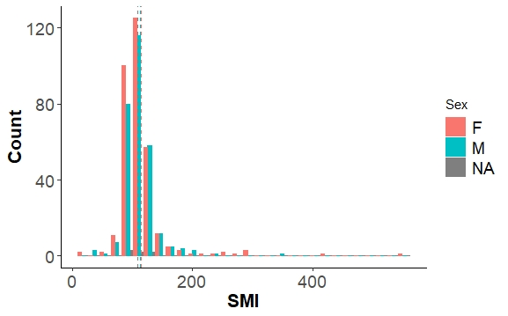

**Figure 4S**. Body mass of Norway and roof rats by trapping area. Roof rats in the natural area had a higher body mass than roof rats in the Bywater, the Lower 9th and the Upper 9th ward.

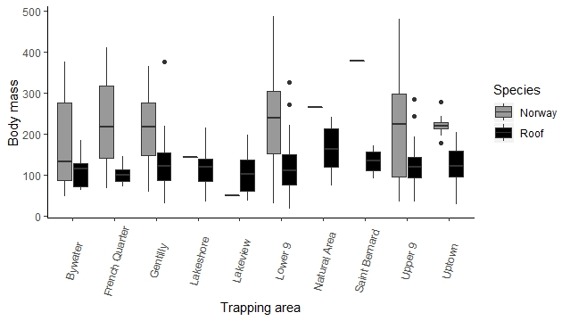

**Figure 5S**. SMI of Norway rats and roof rats by trapping area. Norway rats have a higher SMI than roof rats.

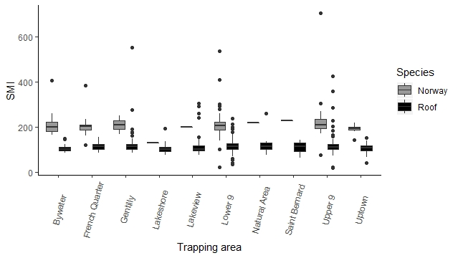

**Figure 6S**. Age distribution of Norway rats (top) and roof rats (bottom) by season and year of trapping.

